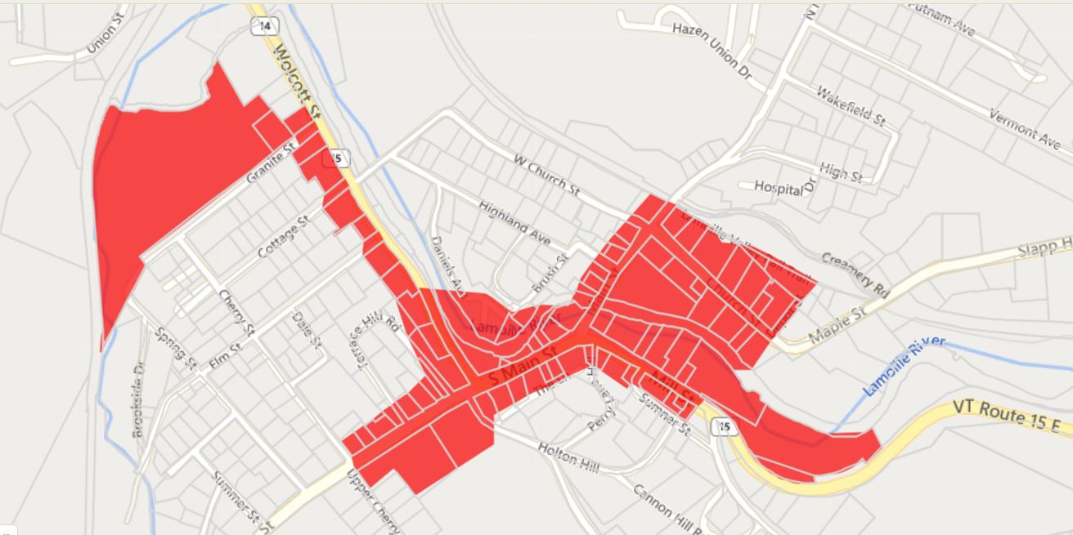
Hardwick Mill & South Main Streets Scoping Study

Designated Downtown is shaded red.
Scoping study project area is shaded orange.
Lamoille Valley Rail Trail
Post Office
Buffalo Mtn. Market
Pedestrian Bridge
Laundromat

